Bees Guided Reading Weekly Plan 07/06/21
The Coral Island by R M Ballantyne  But what fascinated me most were their stories of the southern seas, and of the coral islands of the Pacific. I longed to see these beautiful islands in the tropical sun, with their lush vegetation and white beaches, their reefs formed by tiny creatures. By the time I was fifteen, I was determined to go.  At first my parents said they didn’t want me to travel that far away, but I managed to convince them it was the right thing for me to do. So my father spoke to an old friend of his, the captain of a merchant ship, a large vessel called The Arrow, which would soon be bound for the Pacific Ocean.  A few days later I went on board, and we set sail that same morning. I was very excited as I stood on the deck waving to my parents, the breeze filling the canvas sails above my head, the salt tang of the sea in my nostrils. Little did I know then what an amazing adventure lay in store for me.  There were several boys on the ship, and I made friends with two of them. Jack was eighteen, a tall, broad-shouldered lad. He was mild and quiet, but clever, and good-humoured too. We took to each other straight away. Peter was fourteen, and quite different – he was little and quick and funny, quite mischievous really, although his mischief was completely harmless. | 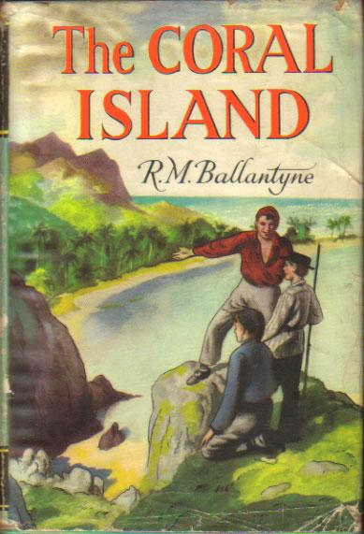  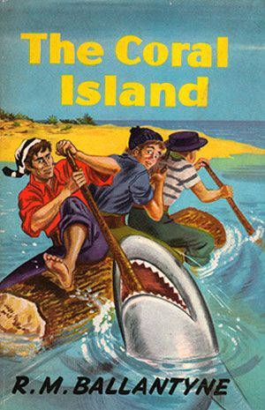
 | Opening task | Follow Up
Tuesday (session 1)  Fluency & understanding | - Listen to Mrs Anderton reading.  - Now, read the text slowly to yourself.  - Whisper it to your reading critter.  - Read the text one more time BUT read each sentence 3 times before moving to the next one. | Complete 3 out of these 6 stem sentences:  - I know this text is about…  - I found this text….  - I like this sentence because…  - This reminds me of…….  - I have never heard of….  - I already know about….
Tuesday (session 2)  Vocabulary development  & Familiarisation | Skim the text. Can you quickly find the following words?  convince lush fascinated mischievous determined | - Write the words and their meanings.  - Write 2 synonyms (words which mean the same) and 1 antonym (word which means the opposite).
Wednesday  Word attack | Read the text again slowly in your head.  Use the new vocabulary from Monday in sentences.  Look at ‘harmless’.  Can you break it apart using your phonics skills? What is the root of the word?  What other words can be made from that word? | Find and copy  - Find and copy one word meaning strong smell or taste.  - Find and copy a group of words that tells you what Ralph’s parents thought about him going to sea.  - Which word most closely matches the definition ‘the plant life of an area?
Thursday  Prosody (reading with appropriate pace and expression) & Prediction | Read it like a rapper. Read it like you’re cold. Read it like a news reader. | How did Ralph feel as he went on board the ship?  Which of Ralph’s new friends was mild and quiet?  How did Ralph change his parents’ minds?
Friday  Focused  Comprehension Skills | Answer the following questions:  What fascinated Ralph the most?  Find three words to describe Peter.  What does Ralph think the Pacific islands will be like? | Extra Challenge  How do we know that Ralph and Jack quickly became friends?  How did Ralph find a ship to go to sea on?  What do you think will happen on Ralph’s voyage?

