Bees Reading Weekly Plan – 19/04/21
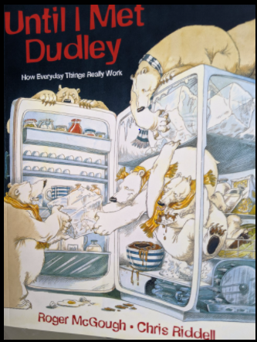
Until I Met Dudley – How does a rubbish truck work?
- A rubbish truck is a big bin on wheels, usually worked by a team of 3 or 4 people. The driver sits in the cab. He keeps the engine running to provide the power for the rubbish truck to do its job.
- The other refuse collectors in the team pick up rubbish bins and heave them onto the platform at the back of the truck…CLONK, CLINK, CLUNK. Clamps hold the bins firmly so they can’t fall off.
- The platform, powered by the trucks engine, swings up….WHIRRR…and tips the rubbish out of the bins, into the truck. Then the platform swings down so the refuse collectors can lift off the empty bins and put them back where they belong.
- Inside the back of the truck there is a wide scoop which operates like a huge hand. It is attached to a powerful arm, called a hydraulic ram. The ram and scoop work together….CRRUNCH…SQUISSH, scooping and squashing the rubbish into the truck.
- Once the truck is full of rubbish, it is driven to the depot where it is emptied. The driver presses another button….WHHIRRR…and the back of the truck tips up. The ejector, a big metal wedge powered by another hydraulic ram, slides backwards….GRRMMMM…to push all the rubbish out of the truck.

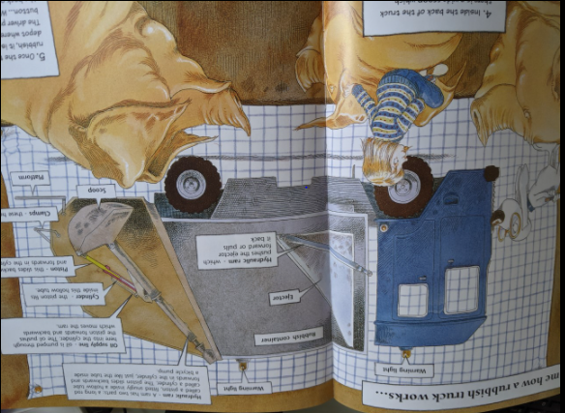

 | Opening task | Follow Up
Monday  Vocabulary development  & Familiarisation | Skim the text. Can you quickly find the following words?  platform heave depot operates  - Write the words and their meanings.  - Write 3 synonyms (words which mean the same). | Complete 3 out of these 6 stem sentences:  - I know this text is about…  - I found this text….  - I like this sentence because…  - This reminds me of…….  - I have never heard of….  - I already know about….
Tuesday  Fluency & understanding | - Listen to Mrs Anderton read the text.  - Now read the text slowly to yourself.  - Whisper the text to your reading critter.  - Read the text one more time BUT read each sentence 3 times before moving to the next one. | Summarise the text in a maximum of 3 sentences or draw a cartoon strip to show the main point.
Wednesday  Word attack | Read the text again slowly in your head.  Use the new vocabulary from Monday in sentences.  Look at the word ‘powered’.  Can you break it apart using your phonics skills? What is the root of the word? What other words can be made from that word? | Find and copy  Often you are asked to ‘Find and Copy’. It is important to be able to find the answers quickly by scanning the text.  - Find and copy the part of the machine which operates like a huge hand.  - Find and copy a group of words that tell you what an ‘ejector’ is.  - What does the ‘hydraulic ram’ do?
Thursday  Prosody (reading with appropriate pace and expression) & Prediction | Read it like a robot. Read it like a newsreader. Read it like it’s the most interesting piece of writing you have ever read! | Why do you think a rubbish truck has about 3 or 4 men?  Why does the driver have to keep the engine running?  What happens when the truck has been emptied for the night?
Friday  Focused Comprehension Skills | Answer the following questions:  - What jobs do the refuse collectors do? Do they all do the same work?  - Do the clamps holding the bins on the platform have to be strong?  - How many bin’s rubbish do you think a rubbish truck could hold?  - Do you think refuse collectors would need to wear particular clothes and gloves? Why? | Extra Challenge  - Why do you think refuse collectors often start work early in the morning?  - Why do you think there is a warning light at the top of the truck?  - Do you think the truck would need regular maintenance? Why?

