Weekly Maths Planning Unit: Division Y6 w/b: 2.11.20
 | Learning objective | Main teaching | Activity | Resources | Vocabulary
Monday | To be able to use short division to divide 4 digit numbers by 2 digit numbers | RECAP: dividing with remainders  Using straws demonstrate questions:  - Tommy has 14 straws. He wants to make them into triangles. How many triangles can he make?  - Dora has 15 straws. She wants to make them into triangles. How many triangles can she make?  - Jack has 16 straws. He wants to make them into triangles. How many triangles can he make?  E.G: 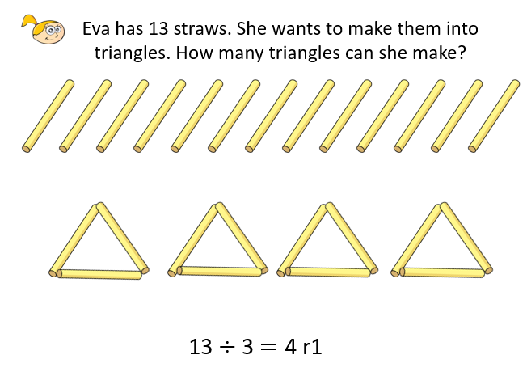  NEW LEARNING:  Use short division -  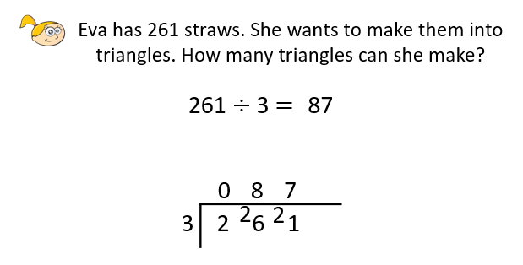 | Work through questions:  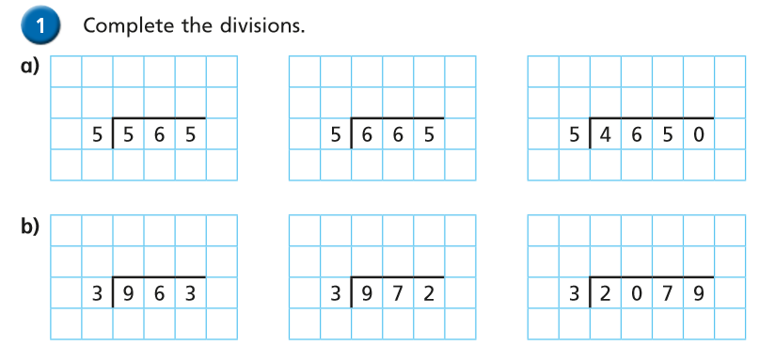  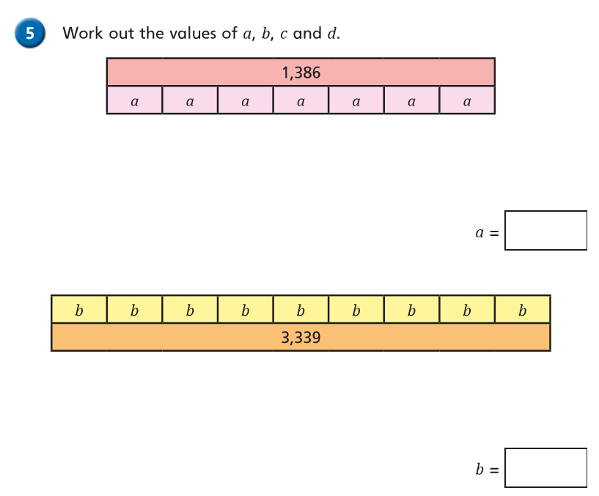 | Straws / sticks | Division  Dividend  Divisor  Quotient
Tuesday | To divide using factors | Watch: https://vimeo.com/461398665 | Complete worksheet | Video link  Worksheet | See above
Wednesday | To be able to use long division | Watch: https://vimeo.com/461800078 | Complete worksheet | Video link  Worksheet | See above
Thursday | To solve problems using long division | Watch: https://vimeo.com/463003643 | Complete worksheet | Video link  Worksheet | See above
Friday | To solve problems using long division | Watch: https://vimeo.com/463003911 | Complete worksheet | Video link  Worksheet | See above

